Smart Shoebox
(Shoes care solution utilizing IoT concept)

Ko ByungHee, Kwon GyuHyeok, Kim JungHyun, Shin MinKi
Information System Department
Hanyang University Engineering School
Seoul, South Korea

Abstract—This document is about the realization of automatic remote control for shoes through IoT. We will make smart shoes cabinet that provides this kind of features with other different kind of functions.
Keywords—shoebox; shoes care; shoes rack; IoT;
Role | Name | Task description etc
User | Kwon GyuHyeok | Suggest the actual features for the Smart Shoebox users can feel comfortable and interesting to use
Customer | Shin MinKi | Suggest the actual features for the Smart Shoebox customers can feel comfortable and interesting to use
Software developer | Kim JungHyun | Focusing on the Technical aspects of the Smart Shoebox while developing  the system
Development manager | Ko ByungHee | Consider the service side of the Smart Shoebox while developing the system

Introduction
Many people experience difficulty managing their own shoes in a decent and pleasant form. Especially for the people living alone, keeping shoes clean and sweet smelling becomes a tough task to manage. When it rains, shoes get wet and dirty. Can you imagine the smell and feel of the shoe? Even worse the smell starts from the entrance to the place where you will go to sleep. This is when the actual management features are required.
What if someone or something could take care of my shoes periodically and automatically. If the shoes could be managed regularly with the aspects of humidity, temperature, and sterilization, it will save money and also provide a pleasant day with a cozy footwear. To realize the concepts of taking care of our shoes, we will develop a shoebox which manages shoes condition by controlling humidity and temperature automatically and periodically.
We are going to use Arduino to support with humidity and temperature recognition by receiving inputs through switches or sensors. Internet of Things (IoT) is also on the base of the idea. The ability to control things (especially shoes in this case) through internet is the main concept we are trying to realize. We are looking forward to create an integrated service tool such as situation awareness, automatic computing, self-growing.

Requirements

Optimizing environment function
When we wear shoes, they easily become in a state of high temperature and humidity which causes the disgusting smell, which is also the best environment for bacteria to grow. As a result, there is a need to control the condition of the cabinet keeping the shoes. To provide an optimized environment automatically and also on user’s demand is the goal.
(There is a need for defining optimized temperature and humidity)

- Temperature/Humidity control through electric fan (automatic)
The sensor receives temperature and humidity as inputs and provides an optimized environment as an output.
- Temperature/Humidity control through ultraviolet lamp (automatic)
The sensor receives temperature and humidity as inputs and provides an optimized temperature and humidity as output.
- Drying feature (on demand)
In case the user’s shoes get wet by rain or other liquids the user can request for drying will operate (1), (2).

- Sterilization function (on demand)
In case the user feels the need for sterilization, user can request for this function, which operates (1), (2).
This function (4) differs from (3) in degrees of intensity.
- Deodorization function (on demand)
In case the user feels the need for deodorization, user can request for this function, which triggers a deodorant to shoot out.
- Deodorization function (automatic)
The user can set regular intervals to trigger the deodorant to shoot out.
- Intensity control feature
The user can choose the intensity level of (1), (2). Intensity is calculated as number between 1 to 5.

Management function
Different type of shoes requires different type of proper cares. The shoe rack needs to understand and recognize the shoes type and provide a proper management for the shoes.
(Modeling : changing ambiguous information into actual concept.)

- Shoe categorization function (bar-code scanning)
Shoe categorization through capturing the barcode for the shoes.
- Shoe categorization function (user input based)
Shoe categorization through selected category of the user.
- Shoe categorization function (captured image)
Shoe categorization through captured images of the shoes.
- Shoe categorization function (3D scanning)
Shoe categorization through 3D scanning of the shoes.
- Setting the proper management tool
After Shoe categorization, based on the shoes category, the shoe rack provides the proper setting.
(There is a need for defining proper setting for each category)
The proper setting is different in the aspect of the intensity from Optimization environment function.

Analysis function
To keep the user’s shoes in high quality we can provide an analysis for the shoes the user own.

- Absence of shoes analysis (Base information)
We have decided to analyze the absence of shoes by sensor and use it as a base information for other analysis functions.
- Durability analysis
Durability is set to decrease by the time the shoe has been put on increases.
- Life prediction analysis
Based on the information of (1), we provide the expected life of the shoes.
- Preference analysis (personal)
Based on the information of (1) for one user, we provide the preference information of the shoes. More the user put on, more the preference increases.

- Preference analysis (general)
Based on the information of (1) for a number of users, we provide the preference information of the shoes for general aspect. Using this Big data, the user can know which shoes are popular nowadays.
- Frequency analysis
Based on the information of (1), we provide the frequency information for the shoes.
- Walking habit analysis (health care)
Based on the information flatness of the shoes , we provide the information about walking habit of the users.

Recommendation function
Smart Shoes cabinet will provide recommendation information with percentages based on different kind of aspects. Of course the final choice is up to the user.

- Recommendation based on weather forecast
With weather API, the proper type of shoes is recommended.
- Recommendation based on the use of shoes
Recommending the shoes type which matches with the user’s activity.
- Recommendation based on the color of shoes
Recommending the shoes color which balances with the users clothing color.
- Notice of recommendation rate by color
Showing the recommendation rate by different colors. For example, if the shoes are recommended, a specific color will appear on the shoe rack or on the screen the user is looking at.
- Notice of recommendation rate by percentage
Showing the recommendation rate by percentage. If the shoes are recommended strongly, the percentage will appear on the shoe rack or on the screen the user is looking at.

Notification function
Shoes easily get dirty, since when people do activities, shoes are the first thing that touches the ground. The shoes cabinet will provide notification for contamination of dirt or rainwater by checking on the weight difference.

- Recognition of contamination by sensor
With the increased weight, notification is given for contamination.
- Notification for contamination by message
After the recognition of contamination, the information is notified to the user through messages.

Networking / Remote control function (UI)
Without the function for internet control, it becomes nothing more than a drying machine. With this networking function on the base, the user is able to take care of the users shoes any time, anywhere. This is the most important feature we will concentrate on. Providing the IoT environment is the main goal.

- Control function through web programming (main)
With web based program, the user can interact with the smart shoe care software and other provided information.
- Control function through mobile (sub)
With mobile application, the user can interact with the smart shoe care software and other provided information.
- Control function through embedded system (sub)
With embedded system, the user can interact with the smart shoe care software and other provided information.

III. Development environment

Choice of software development platform
- Platform used for developing
We will use both Windows and MAC OS . Since Windows is the most popular OS used worldwide and MAC OS is the second most popular OS leaving out all the other versions of Windows. We thought MAC OS X will become more popular. We also thought using other OS besides windows will mean a lot for us to use another environment to develop a software.

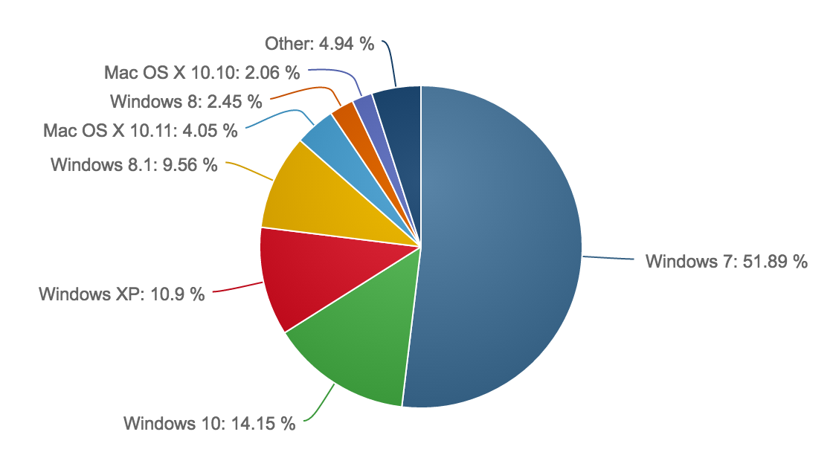
- Market share reports (January, 2016 to March, 2016)
http://www.netmarketshare.com/

- Programming language used for developing

Programming language | Reason
Arduino  (hardware) | The main hardware part of our project is based on Arduino. The Smart Shoebox has functions to work provide behavioral motions such as recognizing the temperature and humidity of the shoebox, turning on the fan or infrared lamp as a result of it and so on.
MySQL  (server side) | We need to have a database to save information about the shoes, users. To easily get and set and manage the information, we have decided to use a database management tool.
Ruby | We first thought of php for the work between the server and web side environment, since we have all learned php in another course. Though we thought it would be much better to learn a new language for this project. Ruby on rails was the interesting programming language in the aspect that it shortens and simplifies the code much more than the php does.
HTML5 & CSS3  (web side) | We have decided the user interface environment as a web-based structure. The functions of Smart Shoebox will be triggered and managed in the web.

- Cost estimation (Software / Hardware)

TABLE I. Hardware in use
Device | Price (won)
Arduino uno R3 | 7,500
Bread board | 2,400
Wifi module  (ESP8266) | 9,000
Temperature Humidity sensor | 3,000
Pressure Sensor | 14,000
Fan(actuator) | 4,000
Board | 2,000
USB cable | 500
jump wire | 2,500
M-F wire | 2,000
Resistance | 200  (5 per unit)
Small LED lamp | 1,000
AA battery | 1,200
transistor | 500
Total | 49,800

TABLE II. Software in use
Software | Task Description | Price
Source Tree(v1.8.3) | Version control | Free
Git(v2.8.1) | Project control | Free
Github | Remote repository  https://github.com/Dpnia/SHOEBOX | Free
Sublime Text3(3103) | Text editor | Free
Mac OS X El Capitan | Operating System | Free
Windows 8 / 10 | Operating System | Free
Arduino(v1.6.8) | Text editor for Arduino | Free
Total | 0

Total cost for both software and hardware in use is 49,800won.

Software in use
We have researched to find out if there is any existing software or algorithm in use doing a similar task we are trying to provide. We were really surprised to find so much information related to our project. There was a lot of algorithms and systems during the research. The most interesting and related ones were the three below.

- Temperature Humidity Control system
As anyone can think of the air conditioner or greenhouse there were already a lot of systems and devices doing the actual part of our project to control the temperature and humidity for the given environment. (For our home, or for growing plants in the optimized temperature and humidity, and so on.) Even there were a lot of information about making the Arduino actually work as we planned to.
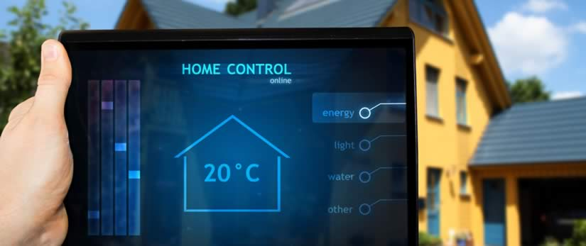
- Advance Temperature Control (http://infusionva.com/)
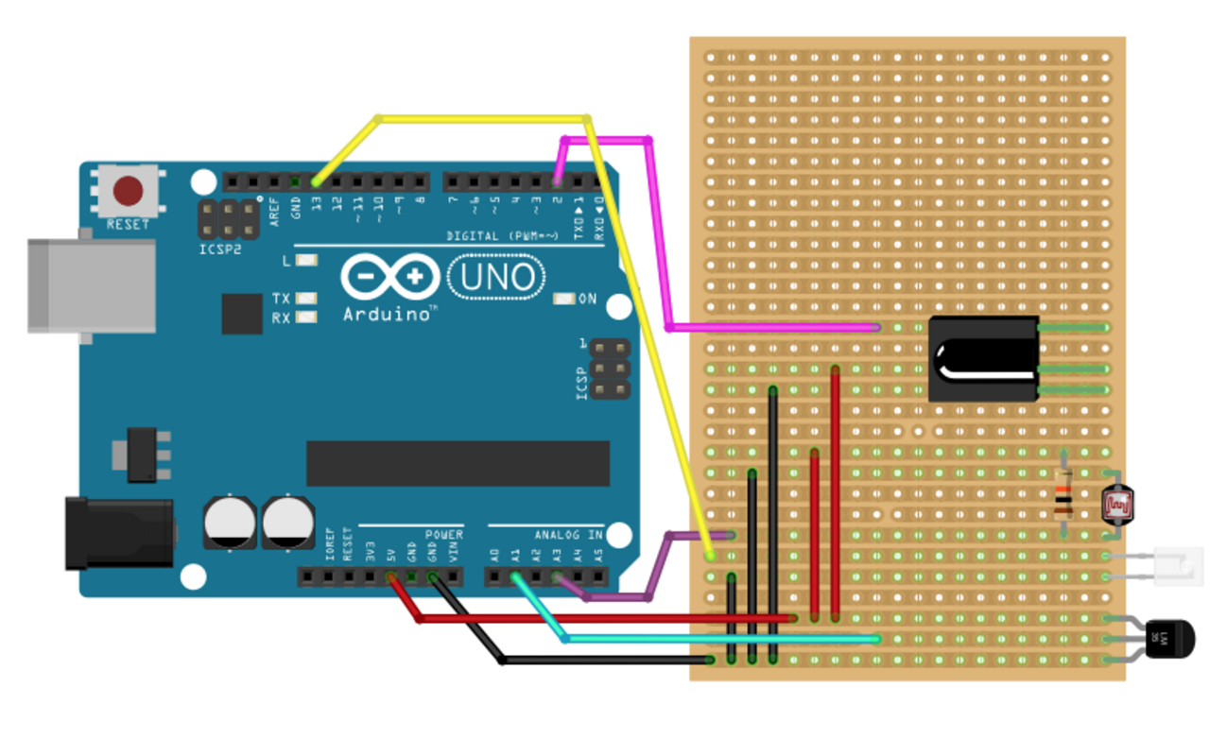
- Airconditioner automatic control through Arduino
- Recommendation System
There is an extensive class of Web applications that involve predicting user responses to options. Such a facility is called a recommendation system.
The Utility Matrix
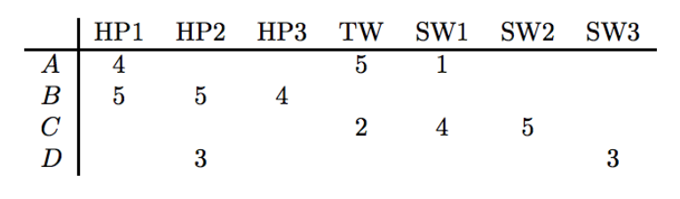
- Example for utility matrix
In Figure above we see an example utility matrix, representing users’ ratings of movies on a 1–5 scale, with 5 the highest rating. Blanks represent the situation where the user has not rated the movie. The movie names are HP1, HP2, and HP3 for Harry Potter I, II, and III, TW for Twilight, and SW1, SW2, and SW3 for Star Wars episodes 1, 2, and 3. The users are represented by capital letters A through D.
The goal of a recommendation system is to predict the blanks in the utility matrix.
This recommendation system was in common with our project in the point that we will provide a recommendation information for the shoes with the weather APT and color of the shoes matching with the user’s clothes.

- Classification Algorithm in datamining
Basic Principle (Inductive Learning Hypothesis): Any hypothesis found to approximate the target function well over a sufficiently large set of training examples will also approximate the target function well over other unobserved examples.
Decision Tree Learning

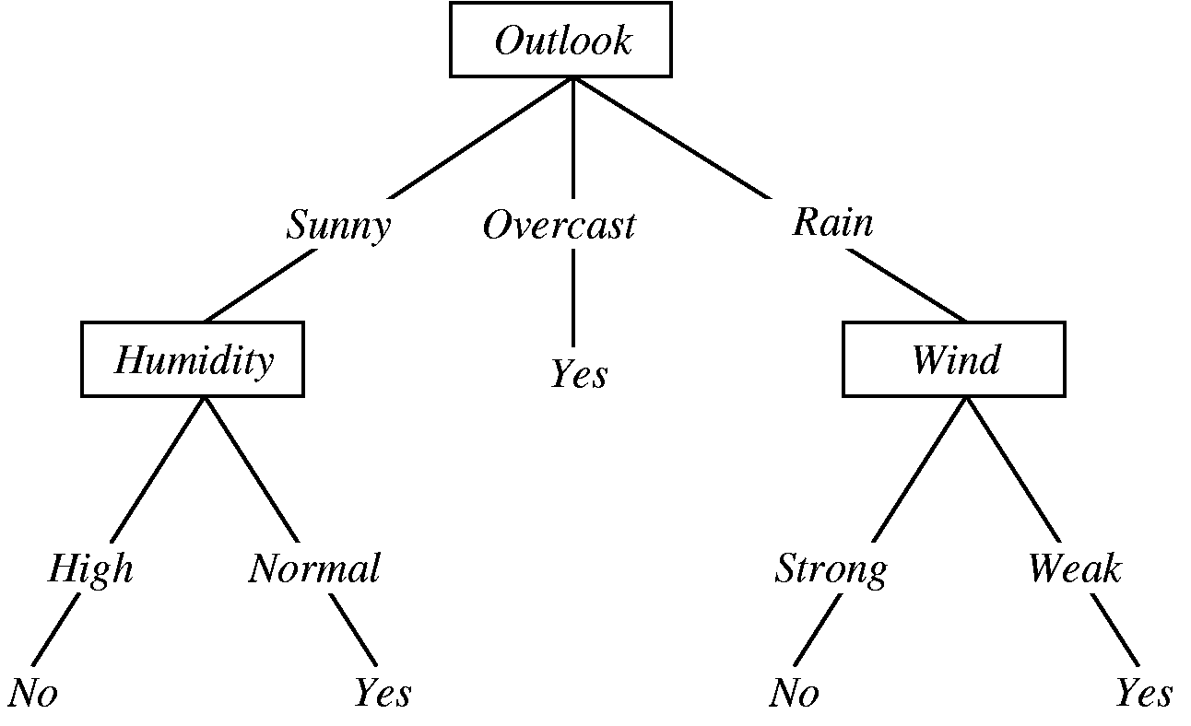
- Example of Decision Tree
This algorithm was in common with our project in the point that we will classify the shoes.

Task distribution
We have decided to distribute the project in big parts to make each participants to be responsible for the assigned parts. Still every person has to know how the project is going on in a big picture while being responsible for the assigned part.

Name | Responsible part
Kwon GyuHyeok | Arduino
Shin MinKi | MySQL
Kim JungHyun | Wireless fidelity control
Ko ByungHee | Ruby on rails

IV. Specifications
The specification is mostly in pseudocode and additionally graphs and charts will be used to specify the requirements. The pseudocode is a little bit close to the programming languages we have already learned during other courses while disregarding the details of the grammar.

Optimizing environment function
- Temperature/Humidity control through electric fan
- Temperature/Humidity control through ultraviolet lamp (both automatic)
The sensor receives temperature and humidity as inputs and provides an optimized environment as an output.
The sensor receives temperature and humidity as inputs and provides an optimized temperature and humidity as output.

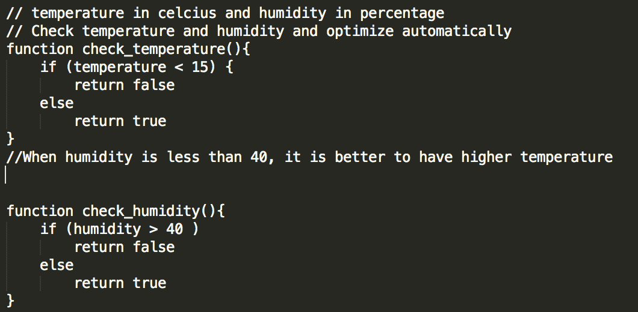

- Drying feature (on demand)
In case the user’s shoes get wet by rain or other liquids the user can request for drying will operate (1), (2).

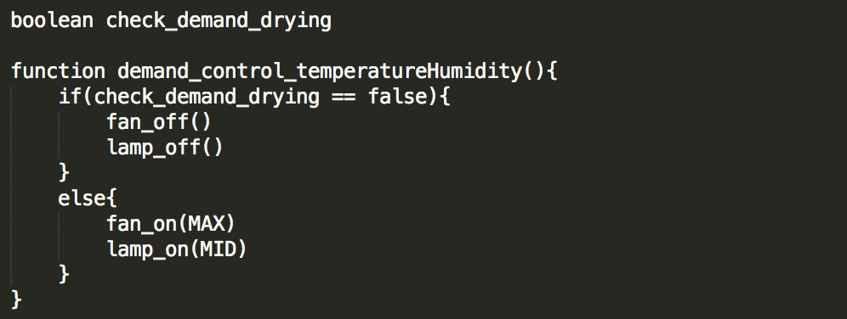

- Sterilization function (on demand)
In case the user feels the need for sterilization, user can request for this function, which operates (1), (2).
This function (4) differs from (3) in degrees of intensity.

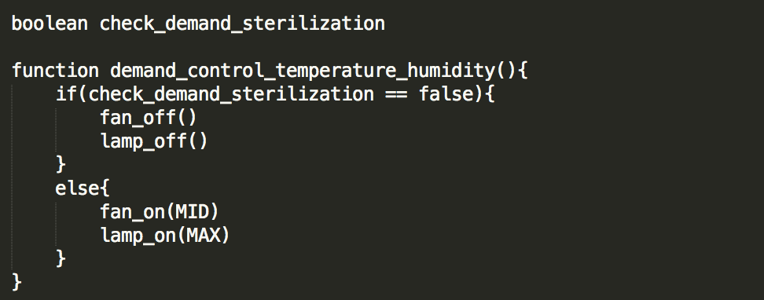

- Deodorization function (on demand)
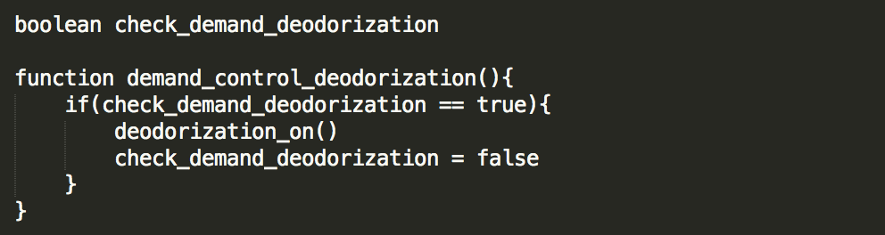

- Deodorization function (automatic)
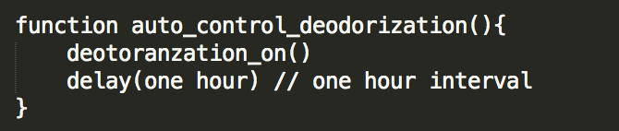

- Intensity control feature
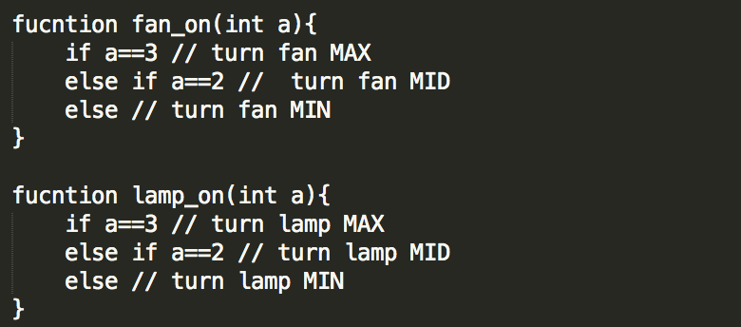

Management function
This management function is mostly about modeling and categorizing the shoes. Through the serial number scanning, captured image, 3D scanning and user input, the information about the user and shoes are managed in the database.
- Shoe categorization function (serial number scanning)
- Shoe categorization function (user input based)
- Shoe categorization function (captured image)
- Shoe categorization function (3D scanning)
- Setting the proper management tool

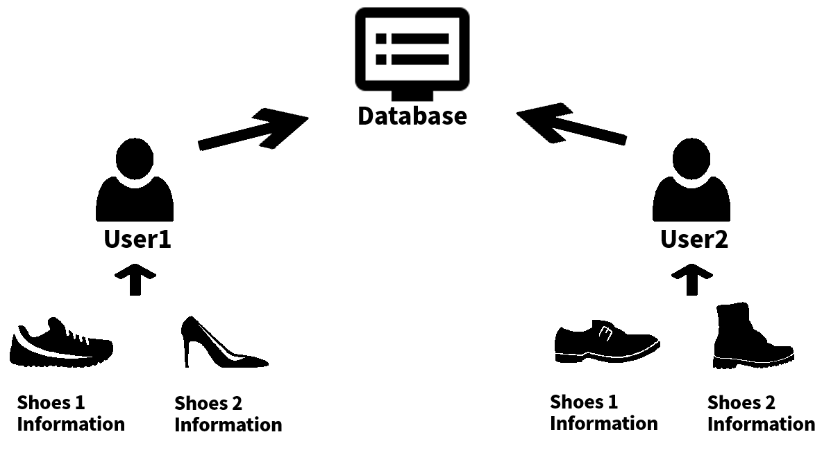
- Shoe information into the database
The big arrow pointing to the database will be one of the ways of receiving the information of the shoes by the user. Like we mentioned at above part the ways will be the serial number scanning, analyzing the captured image, 3D scanning and analyzing user input.

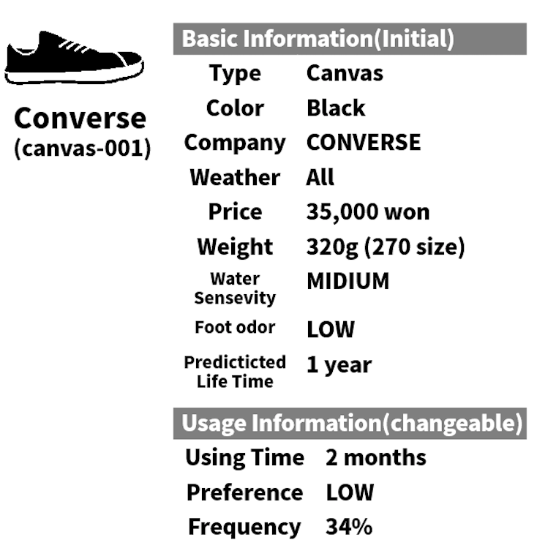
- Example of the shoes modeling I

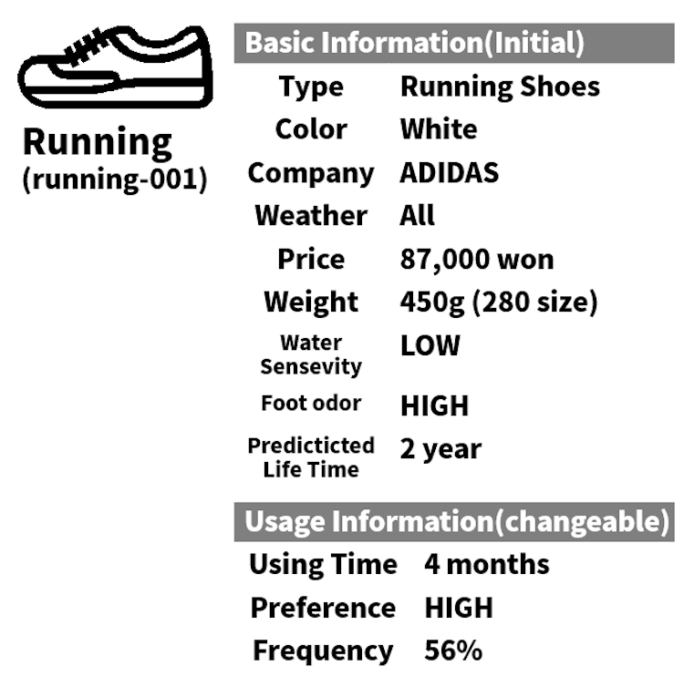
- Example of the shoes modeling II

The saved information of the shoes will be assigned to each model we will provide before. For each model the proper care solution will be provided.
The modeling of each shoe into a number of category and setting the proper care solution will be the most important part to realize this function. Also at the same time it is the most ambiguous part before the design phase.

Analysis function
- Absence of shoes analysis (Base information)
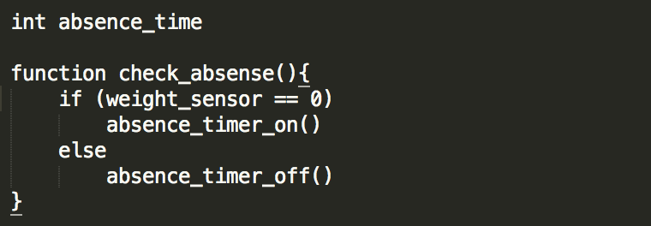

- Durability analysis
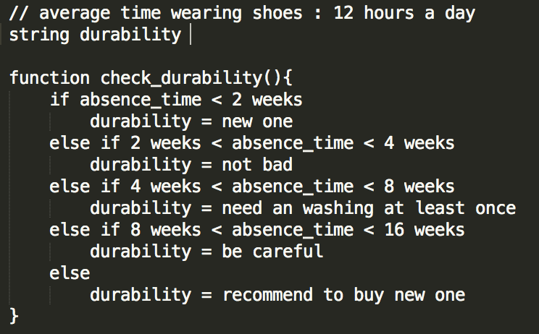

- Life prediction analysis
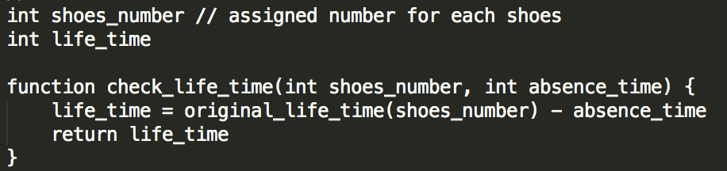

- Preference analysis (personal)
- Preference analysis (general)
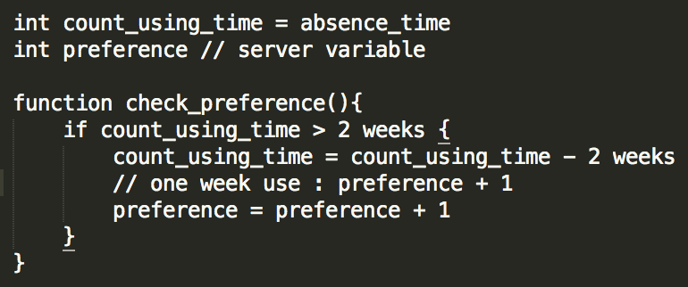

- Frequency analysis
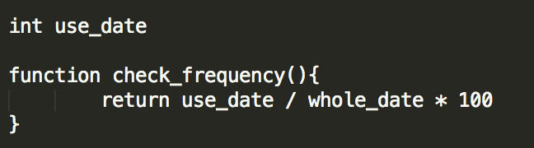

Recommendation function
- Recommendation based on weather forecast
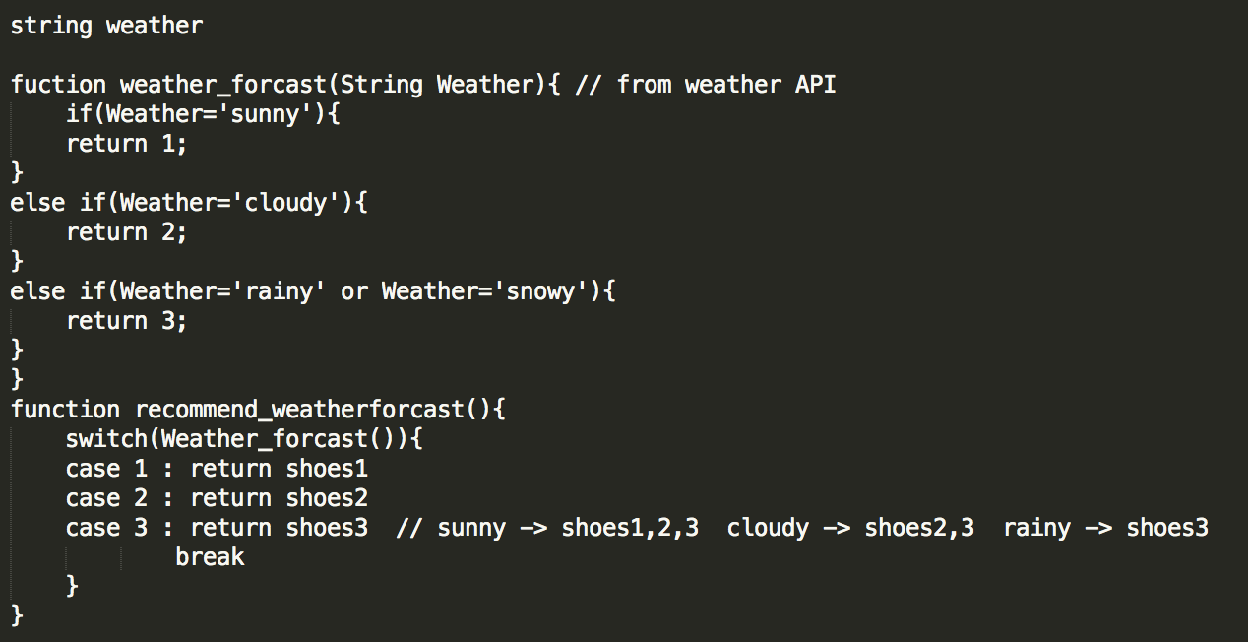

- Recommendation based on the use of shoes
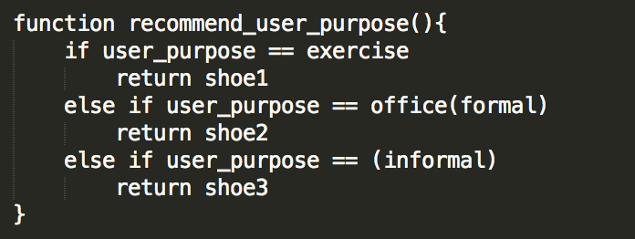
casual
- Recommendation based on the color of shoes
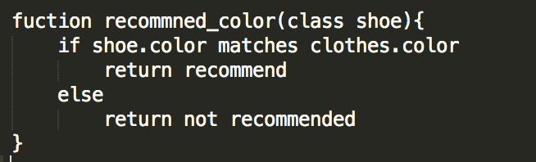

- Notice of recommendation rate by color
- Notice of recommendation rate by percentage
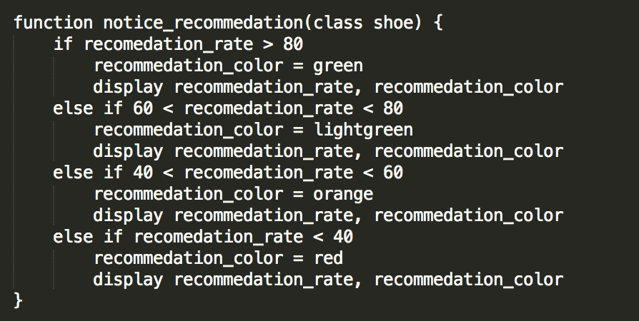

Notification function
- Recognition of contamination by sensor
- Notification for contamination by message
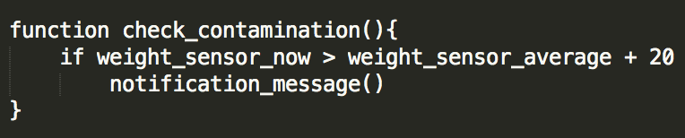

Networking / Remote control function (UI)
- Control function through web programming (main)
- Control function through mobile (sub)
- Control function through embedded system (sub)
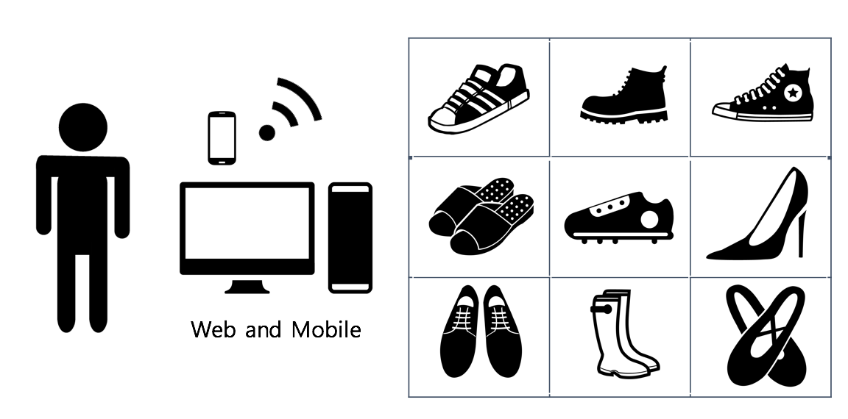
- Networking function through mobile and web
To realize this function we will provide a user interface through mainly web and additionally mobile and a screen for the Smart Shoebox. The already mentioned functions before will be on the UI so that the user can interact with the system. The temperature and humidity will be provided on the screen the user will be seeing. Optimaization function, management function, analysis function, recommendation function, notification function will be on the main screen for users be able to use.
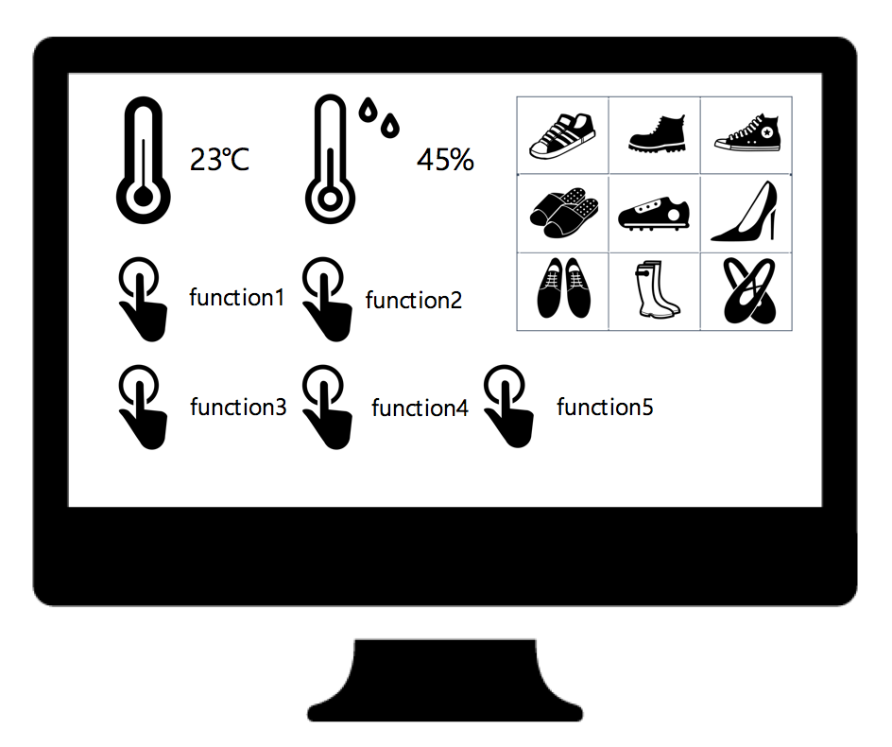
- Example for the UI of the Smart Shoebox

References
- http://www.netmarketshare.com/
- http://infolab.stanford.edu/~ullman/mmds/ch9.pdf.

